Access Sheridan

Revised Wireframes

SYST15829 - Interactive

Guided under - Professor Himanshu
Date of Submission: Friday, April 10th, 2020

Group Members: Daniel Ball, Minh Nguyen,
Nicholas Razack, Xingning Xu and Zawad Hossain

Roles
Daniel Ball (Contributor):
Minh Nguyen (Wireframe):
Nicholas Razack (Contributor):
Xingnig Xu (Editor):
Zawad Hossain (Documentation):

Survey Results
The survey results gave us more insight on the student portal design we made. Testers pointed out the following areas that need improvements (See more on summary of each wireframe pairs):
- Change the color scheme, it is distracting when the colors are too bright or too many.
- Change the font to make the labels look more clear.
- Allow the user to edit and make his own reminders in the Calendar.
- Include a search button for the library search page.
- Better looking login page with welcome notice to indicate where the user is.

Wireframes of Access Sheridan

Initial Login Page Wireframe
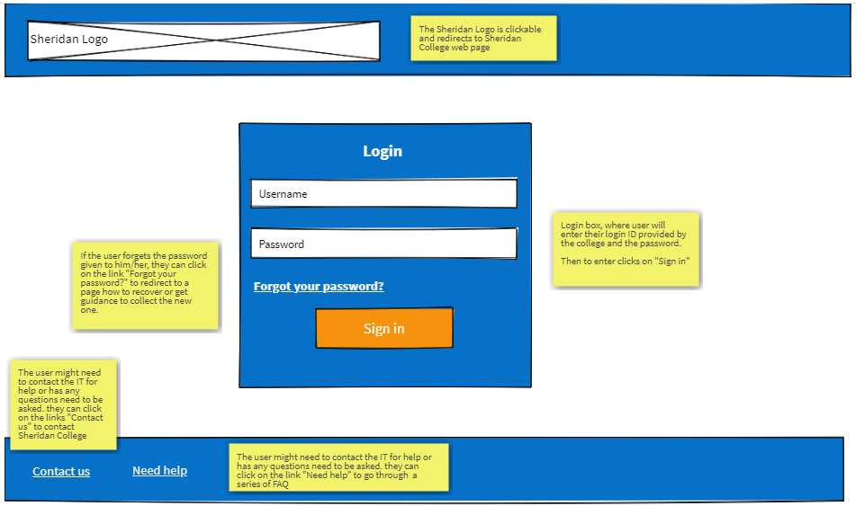
Figure 1a: Initial wireframe for our login page (wireframe pro)
Revised Login Page Wireframe 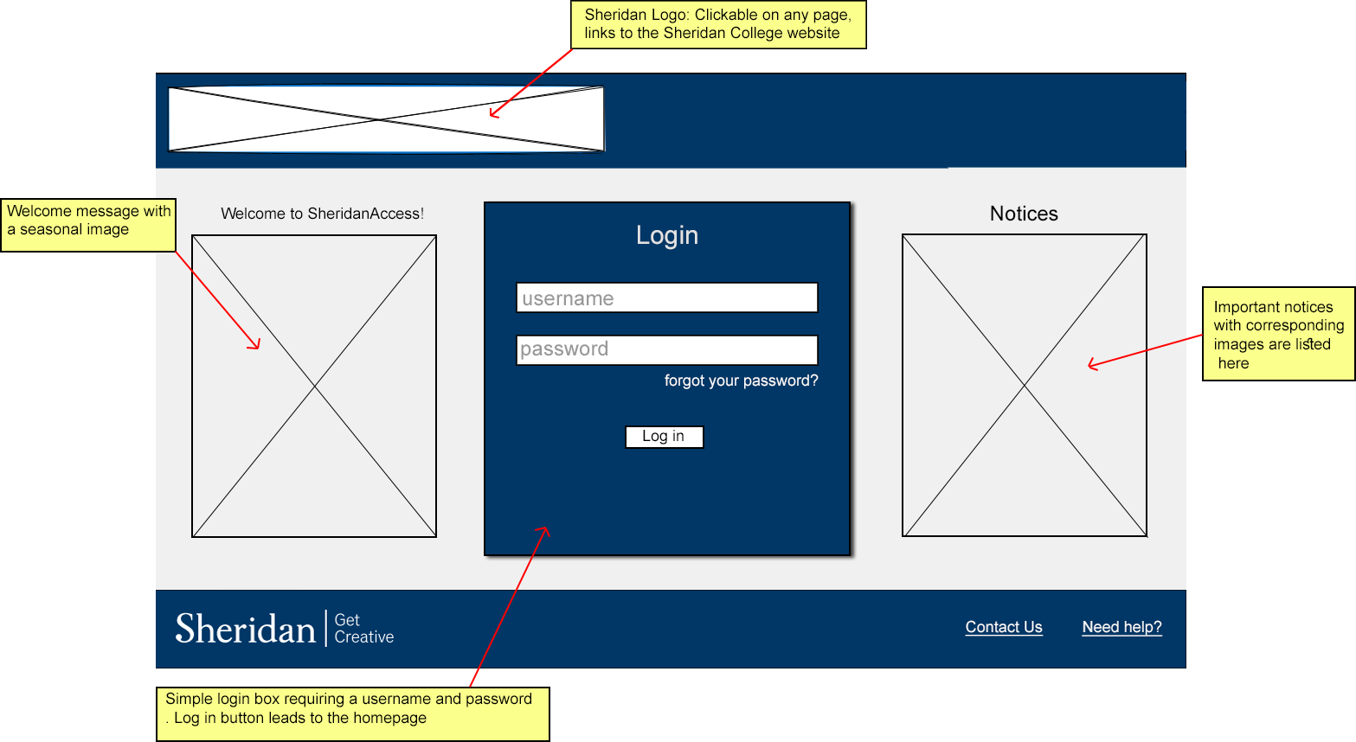
Figure 1b: Revised wireframe of login page
We changed the color scheme to a darker shade throughout the webpage and kept our login page simple. We added welcome notices to indicate that this is the login page according to suggestions from the user feedback. We also changed the header and footer of the web page to give it a more professional look.
Initial Landing Page Wireframe
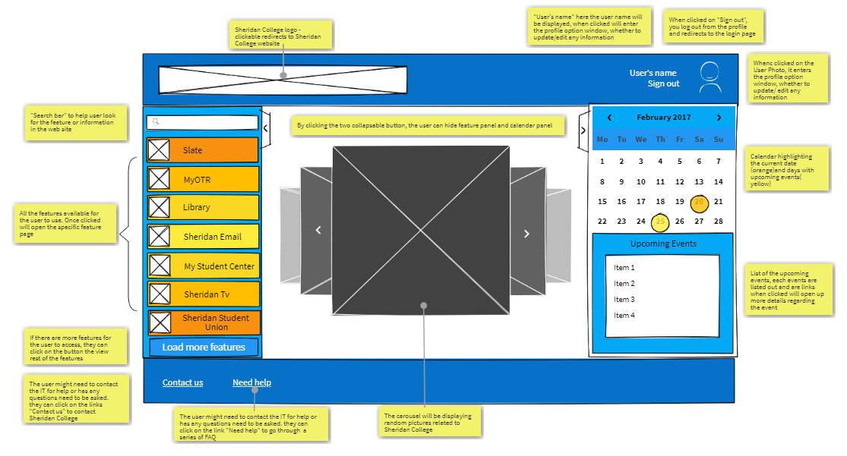
Figure 2a: Initial wireframe for our landing page (wireframe pro)

Revised Landing Page Wireframe
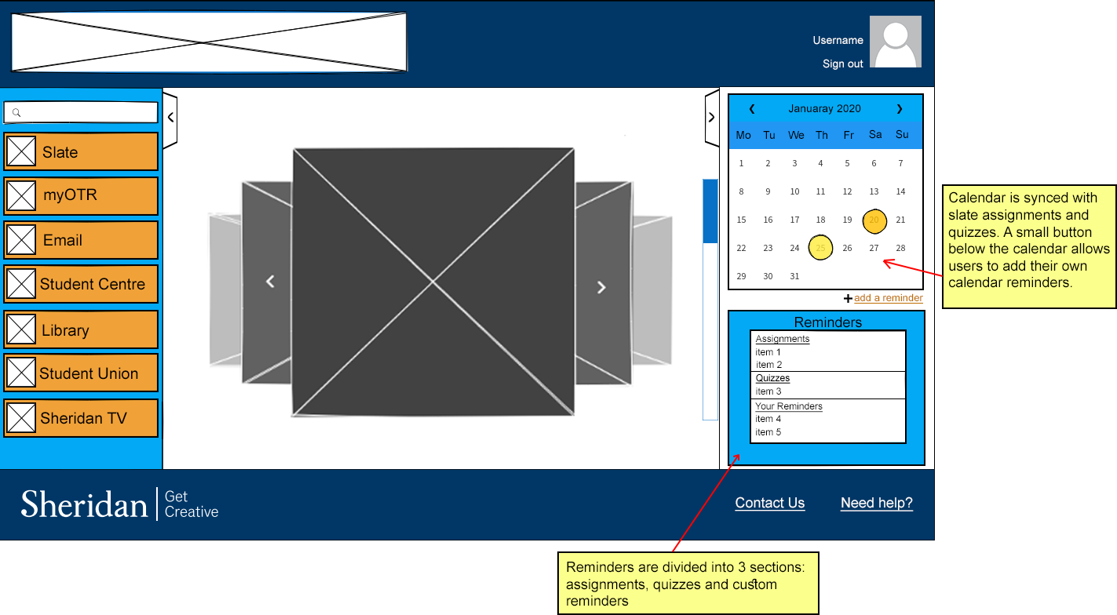
Figure 2b: Revised wireframe for our landing page
The color scheme for the Feature tabs on the left side is changed. Initial wireframe had a gradient of orange, now we simply stick to one shade. The darker shade of blue color is used throughout our webpage theme to give the website a distinct look that the users can become familiar with. The font is also adjusted to make the labels on the tabs more clear. We also changed the user profile pic logo on the top right corner. A new feature is added to the personal calendars to allow users to add their own reminders.

Initial Search Page
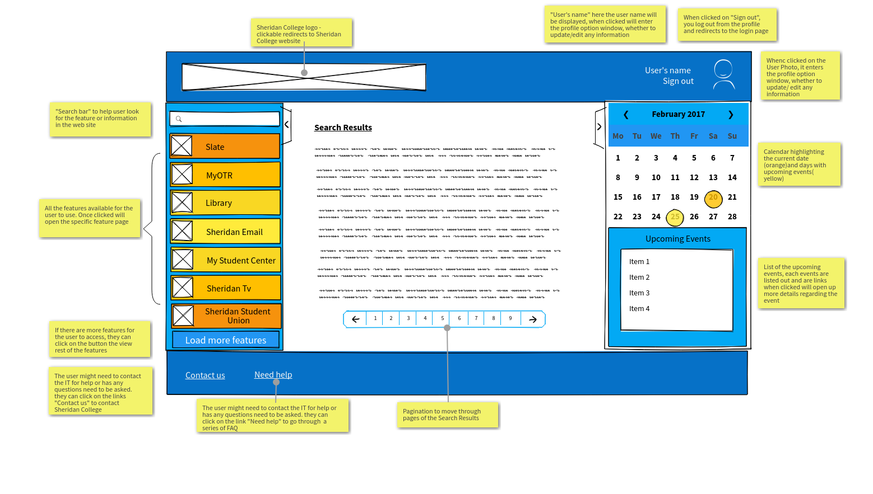
Figure 3a: Initial wireframe for our search result page (wireframe pro)

Revised Search Page
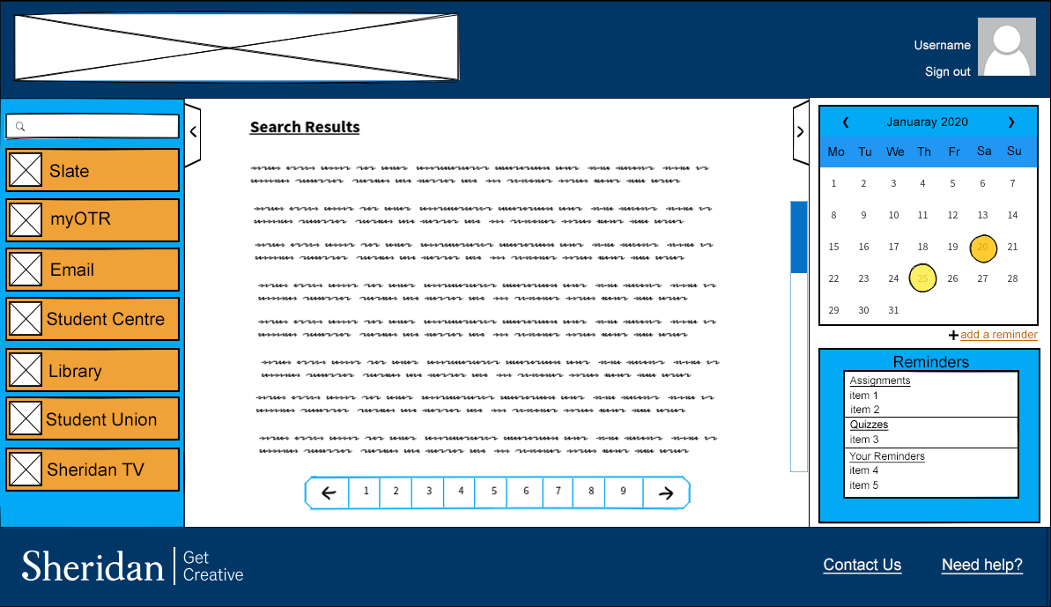
Figure 3b: Revised wireframe for our search result page
We just changed the color scheme and adjusted the header and footer to be consistent with the revised wireframes.

Initial Slate Page
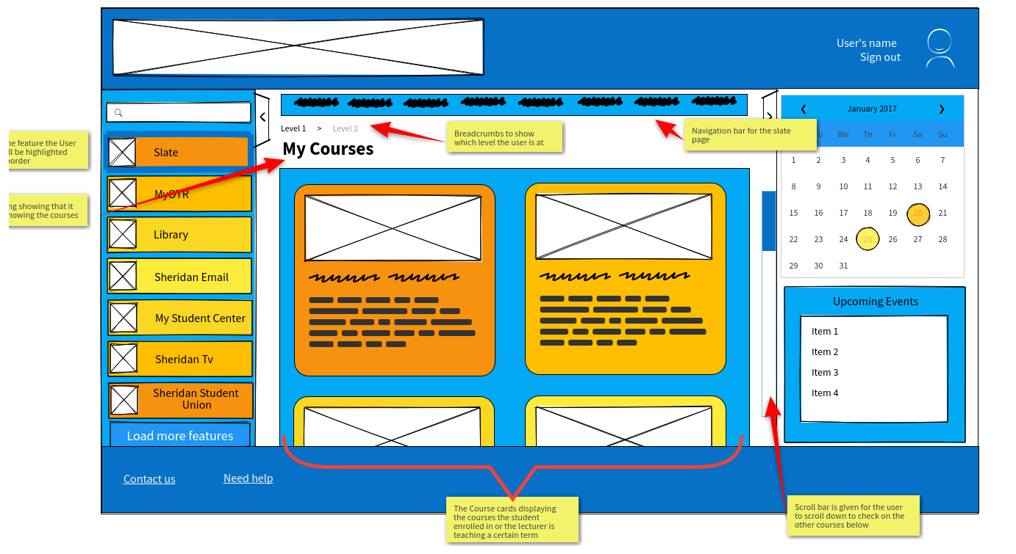
Figure 4a: Initial wireframe for our Slate page (wireframe pro)

Revised Slate Page
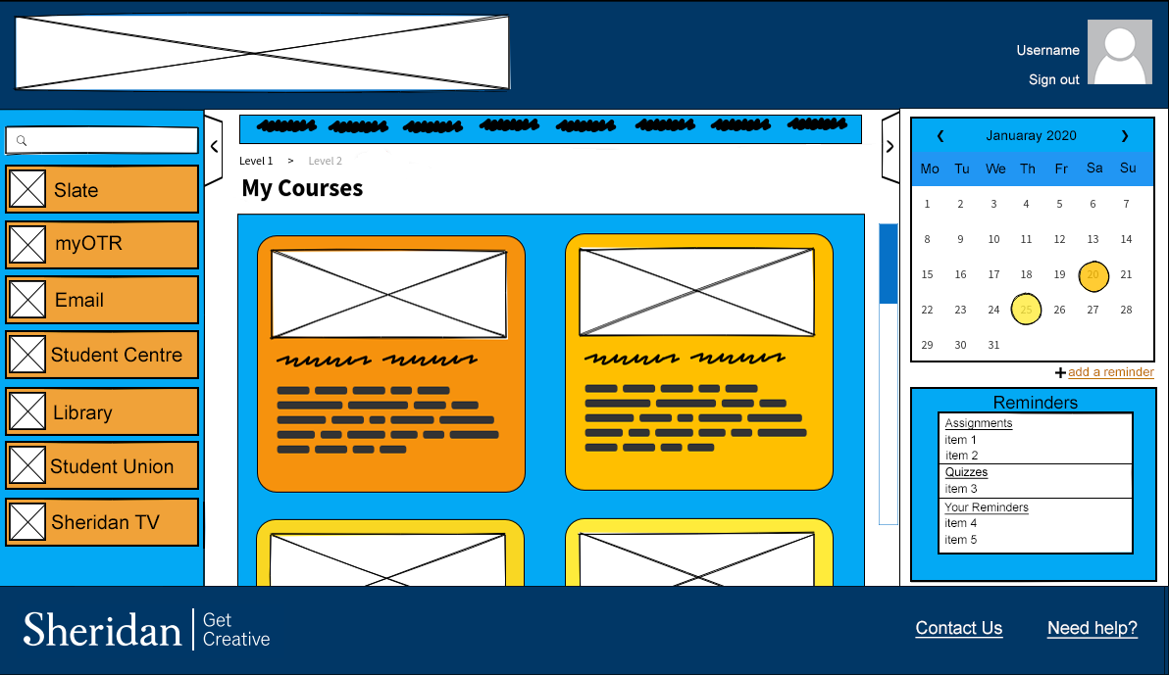
Figure 4b: Revised wireframe for our Slate page
We changed the color to be consistent with the revised wireframes and renaming the “Upcoming Events” to “Reminders” for a better understanding of what it does.

Initial My OTR Page
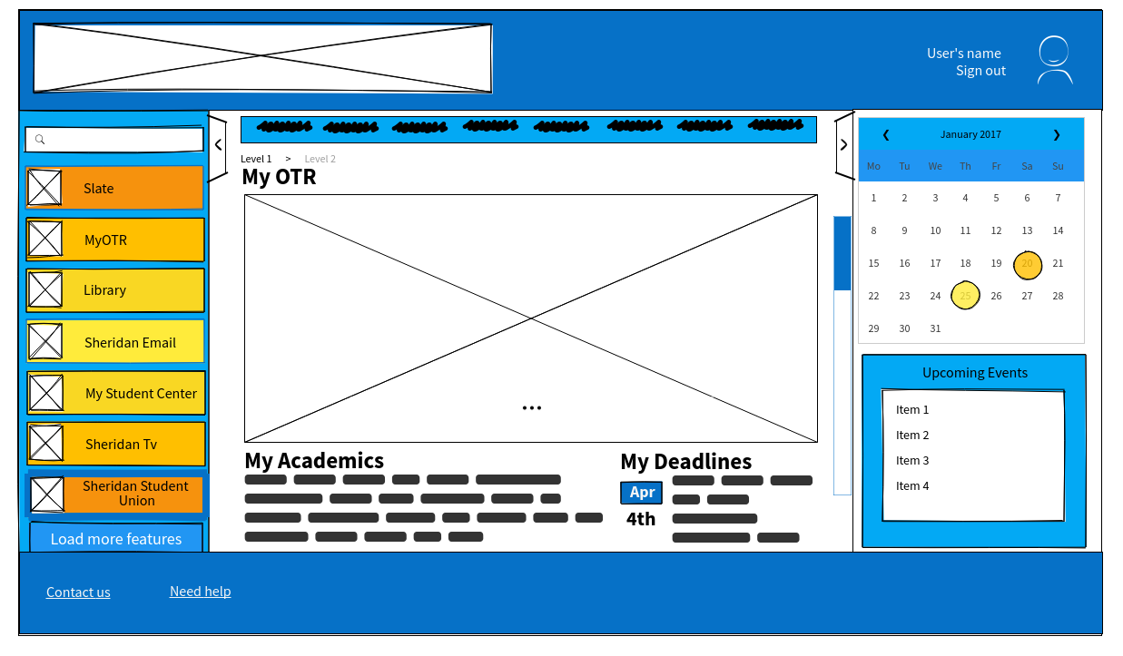
Figure 5a: Initial wireframe for our MyOTR page (wireframe pro)

Revised My OTR Page
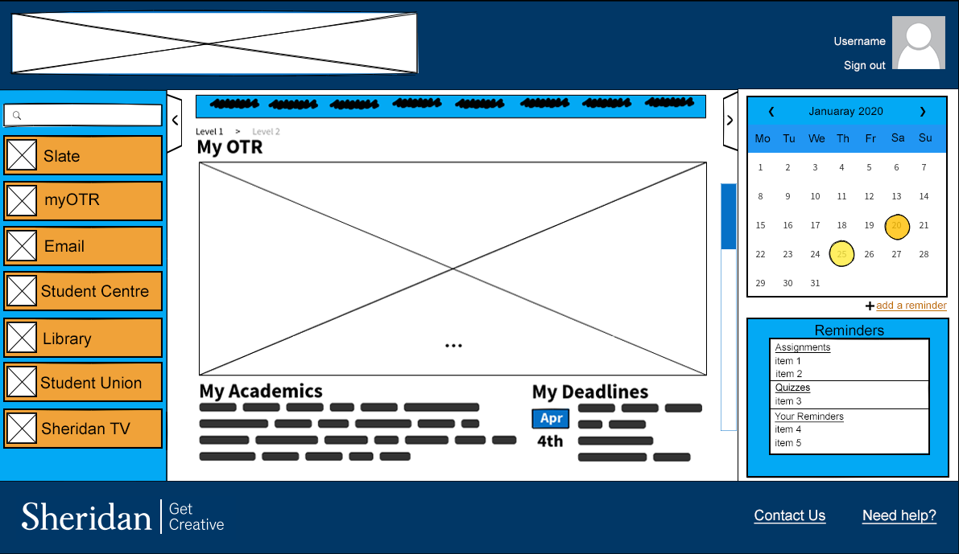
Figure 5b: Revised wireframe for our MyOTR page
we changed the color to be consistent with the revised wireframes.

Initial Sheridan Email Page
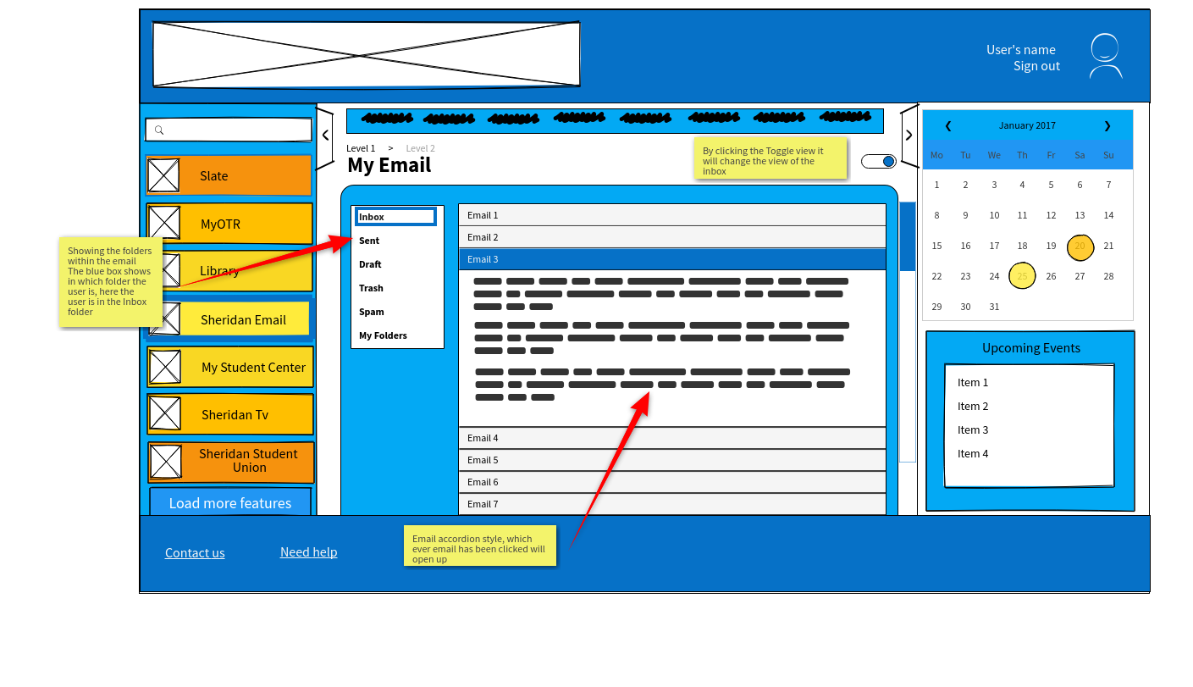
Figure 6a: Initial wireframe for our Sheridan Email page (wireframe pro)

Revised Sheridan Email Page
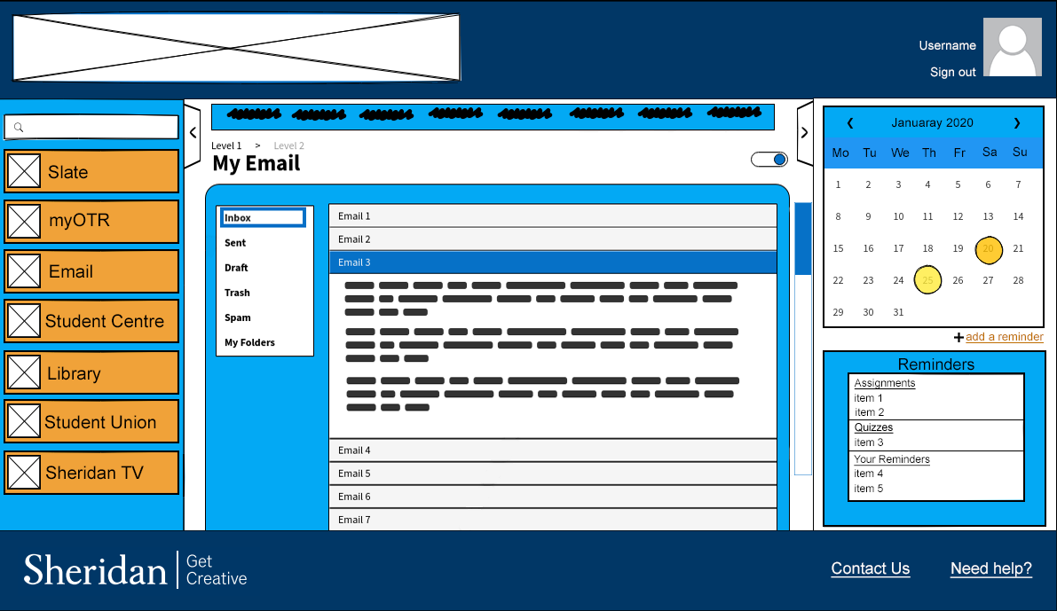
Figure 6b: Revised wire frame for our Sheridan Email page

We changed the color to be consistent with the revised wireframes

Initial Sheridan Student Union Page
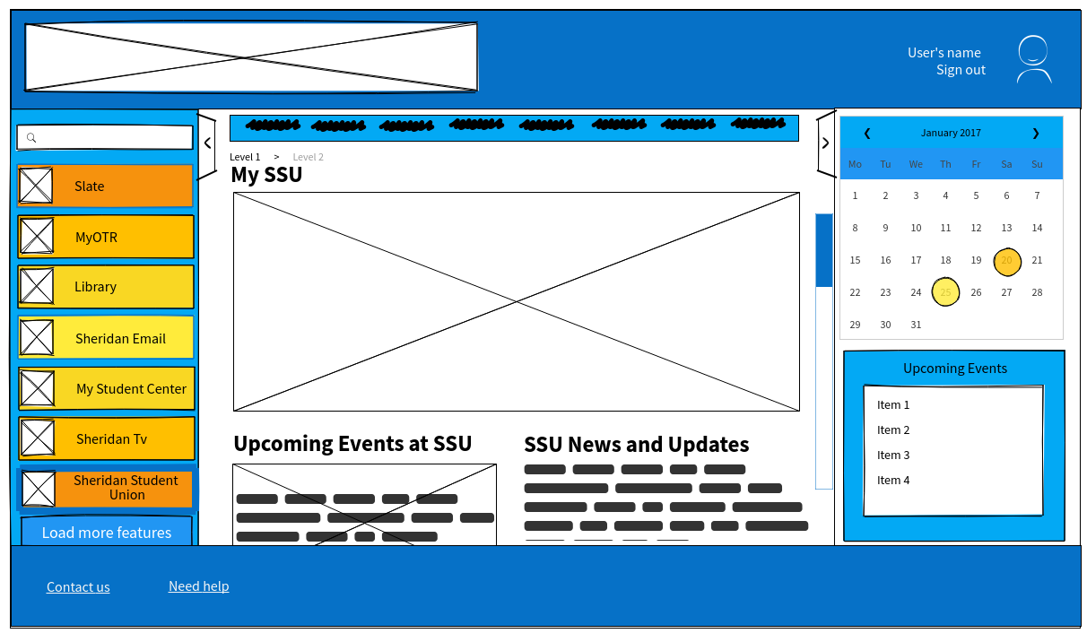
Figure 7a: Initial wireframe for our Sheridan Student Union page (wireframe pro)

Revised Sheridan Student Union Page

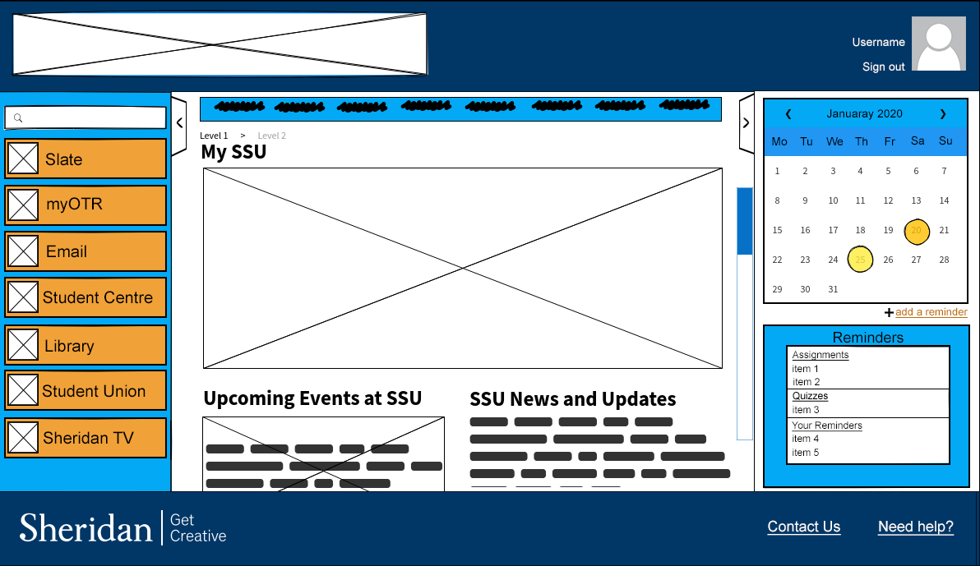
Figure 7b: Revised wireframe for our Sheridan Student Union page

We changed the color to be consistent with the revised wireframes.
Initial Library Services Page
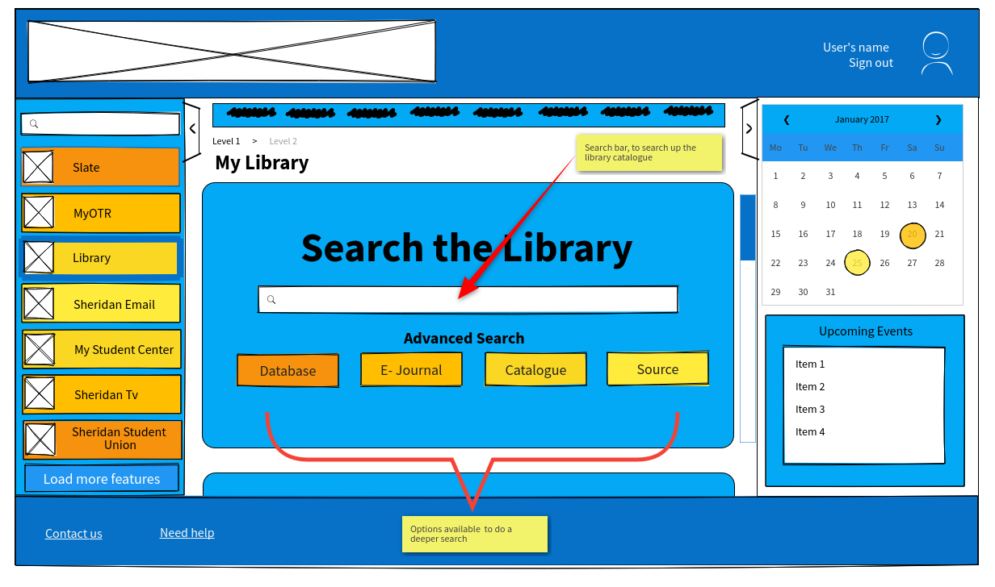
Figure 8a: Initial wireframe for our Library Services page (wireframe pro)

Revised Library Services Page
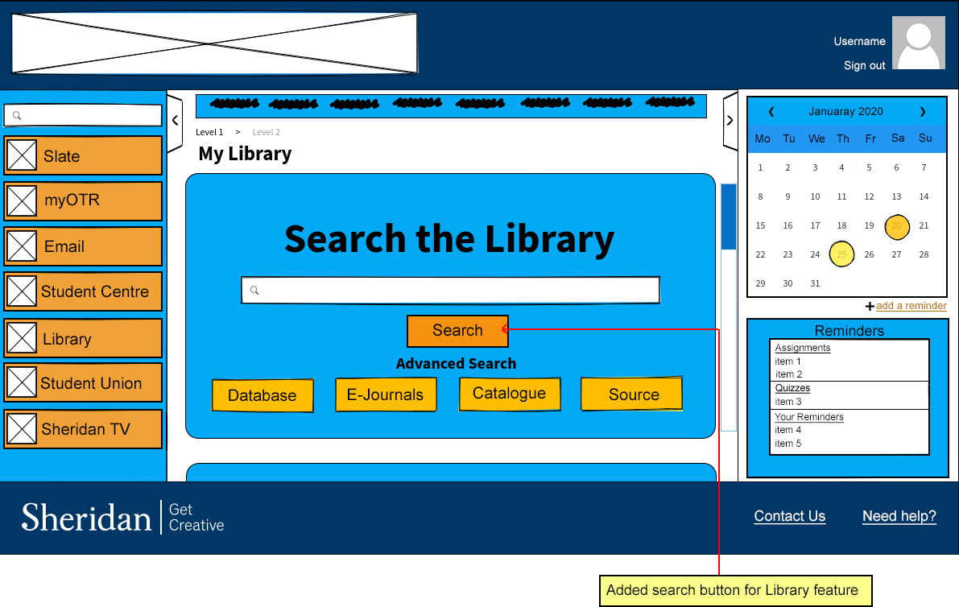
Figure 8b: Revised wireframe for our Library Services page
In this page we added the “Search” button as suggested by one of the users.

